DMV Assignment 3

Syed Muhammad Hassan Raza - 26645

**1) Write a SQL query to find the first name, last name, department number, and department ID for each employee.**

SELECT A.FIRST_NAME, A.LAST_NAME, A.DEPARTMENT_ID, B.DEPARTMENT_NAME

FROM DBO.OEHR_EMPLOYEES A

JOIN DBO.OEHR_DEPARTMENTS B

ON A.DEPARTMENT_ID = B.DEPARTMENT_ID

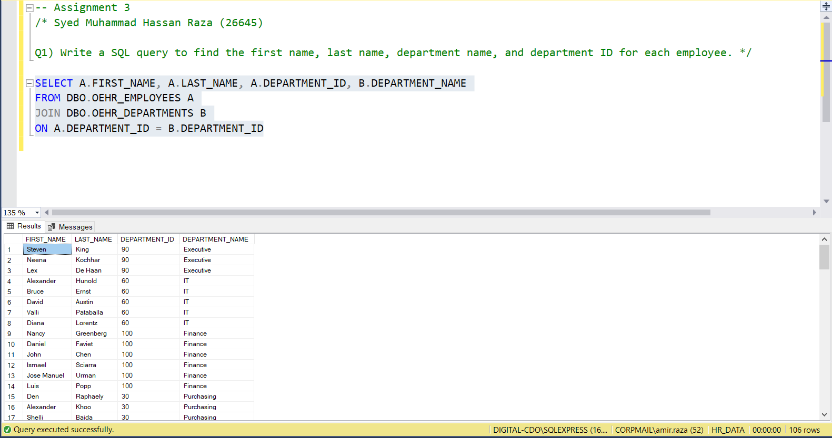

**2) Write a SQL query to find all those employees who work in department ID 80 or 40. Return first name, last name, department ID and department name.**

SELECT A.FIRST_NAME, A.LAST_NAME, A.DEPARTMENT_ID, B.DEPARTMENT_NAME

FROM DBO.OEHR_EMPLOYEES A

LEFT JOIN DBO.OEHR_DEPARTMENTS B

ON A.DEPARTMENT_ID = B.DEPARTMENT_ID

WHERE A.DEPARTMENT_ID IN (80,40)

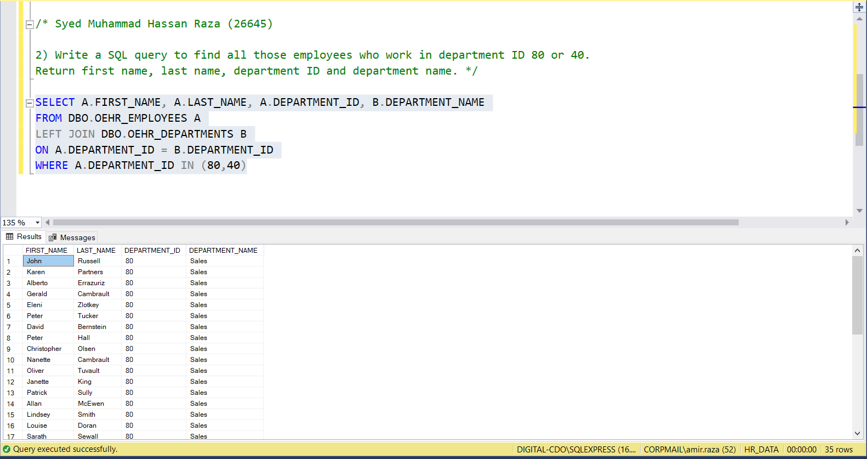

**3) Write a SQL query to find those employees whose first name contains the letter "z". Return first name, last name, department ID and department name.**

SELECT A.FIRST_NAME, A.LAST_NAME, A.DEPARTMENT_ID, B.DEPARTMENT_NAME

FROM DBO.OEHR_EMPLOYEES A

LEFT JOIN DBO.OEHR_DEPARTMENTS B

ON A.DEPARTMENT_ID = B.DEPARTMENT_ID

WHERE FIRST_NAME LIKE '%Z%'

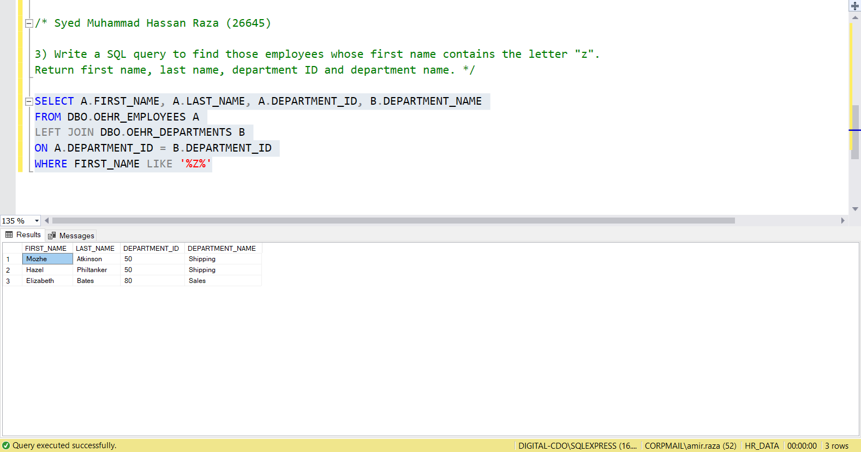

**4) Write a SQL query to find all departments, including those without employees. Return first name, last name, department ID, department name.**

SELECT A.FIRST_NAME, A.LAST_NAME, A.DEPARTMENT_ID, B.DEPARTMENT_NAME

FROM DBO.OEHR_EMPLOYEES A

RIGHT JOIN DBO.OEHR_DEPARTMENTS B

ON A.DEPARTMENT_ID = B.DEPARTMENT_ID

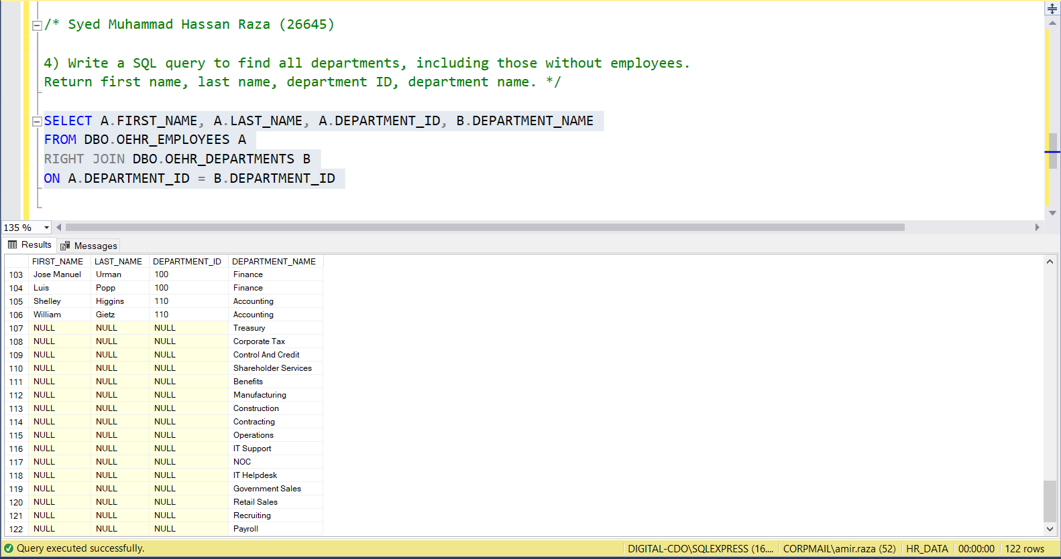

**5) Write a SQL query to display the department name, city, and state province for each department. Show the results from both the tables even if you don't find their matching results in the tables.**

SELECT A.DEPARTMENT_NAME, B.CITY, B.STATE_PROVINCE

FROM DBO.OEHR_DEPARTMENTS A

FULL JOIN DBO.OEHR_LOCATIONS B

ON A.LOCATION_ID = B.LOCATION_ID

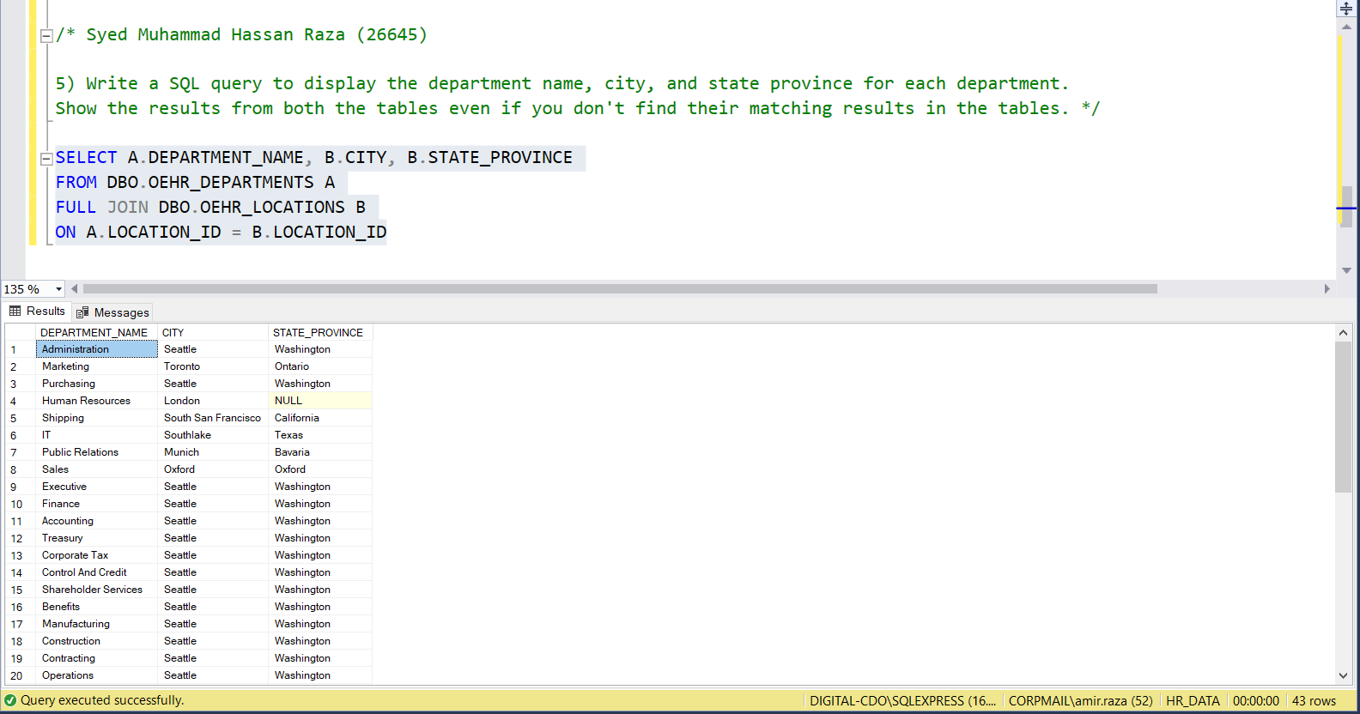

**6) Write a SQL query to find out which employees have or do not have a department. Return first name, last name, department ID, department name.**

SELECT A.FIRST_NAME, A.LAST_NAME, A.DEPARTMENT_ID, B.DEPARTMENT_NAME

FROM DBO.OEHR_EMPLOYEES A

LEFT JOIN DBO.OEHR_DEPARTMENTS B

ON A.DEPARTMENT_ID = B.DEPARTMENT_ID

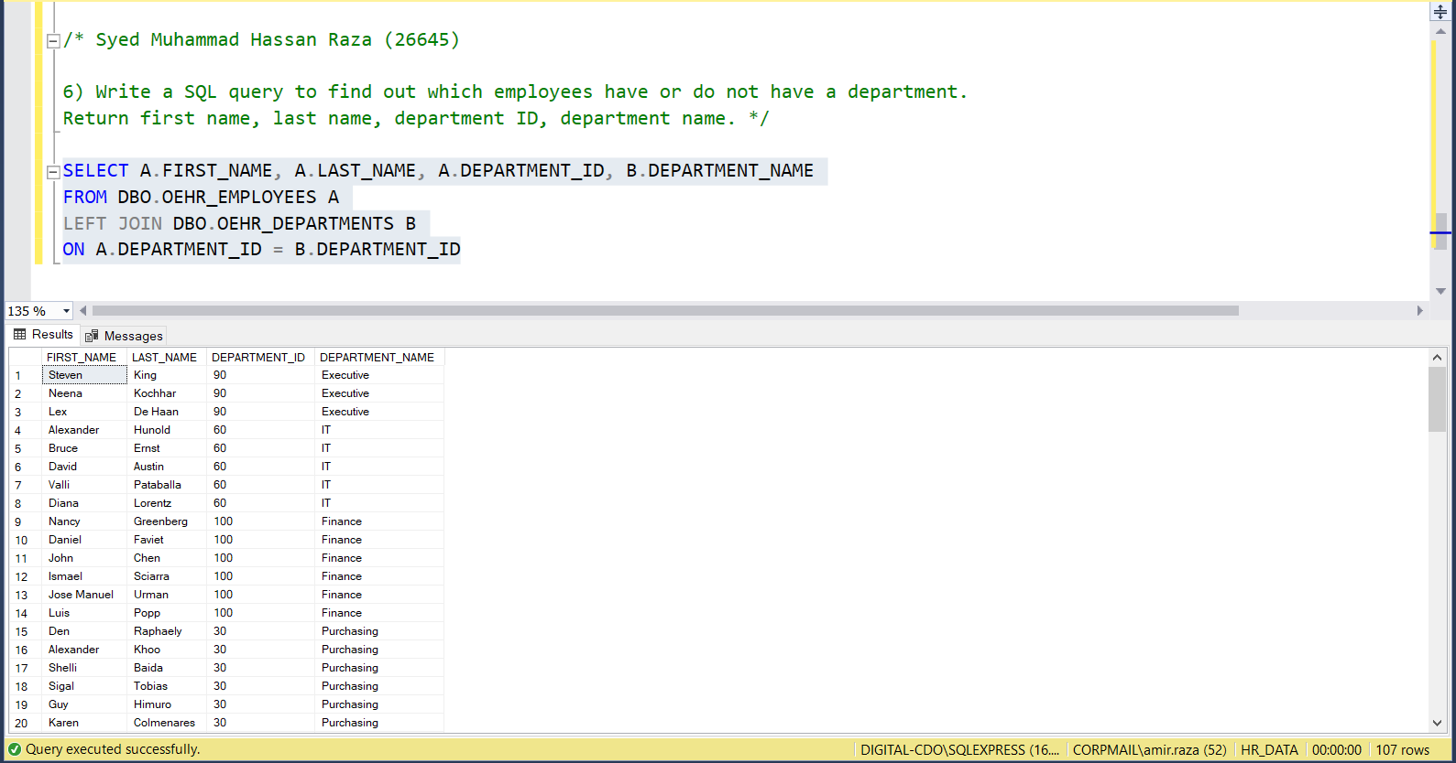

**7) Write a SQL query to calculate the average salary, and total employees. Return department name (Not department ID), average salary of that department and number of employees in that department.**

SELECT B.DEPARTMENT_NAME, AVG(A.SALARY) 'AVERAGE SALARY', COUNT(A.EMPLOYEE_ID) 'TOTAL EMPLOYEES'

FROM DBO.OEHR_EMPLOYEES A

FULL JOIN DBO.OEHR_DEPARTMENTS B

ON A.DEPARTMENT_ID = B.DEPARTMENT_ID

GROUP BY B.DEPARTMENT_NAME

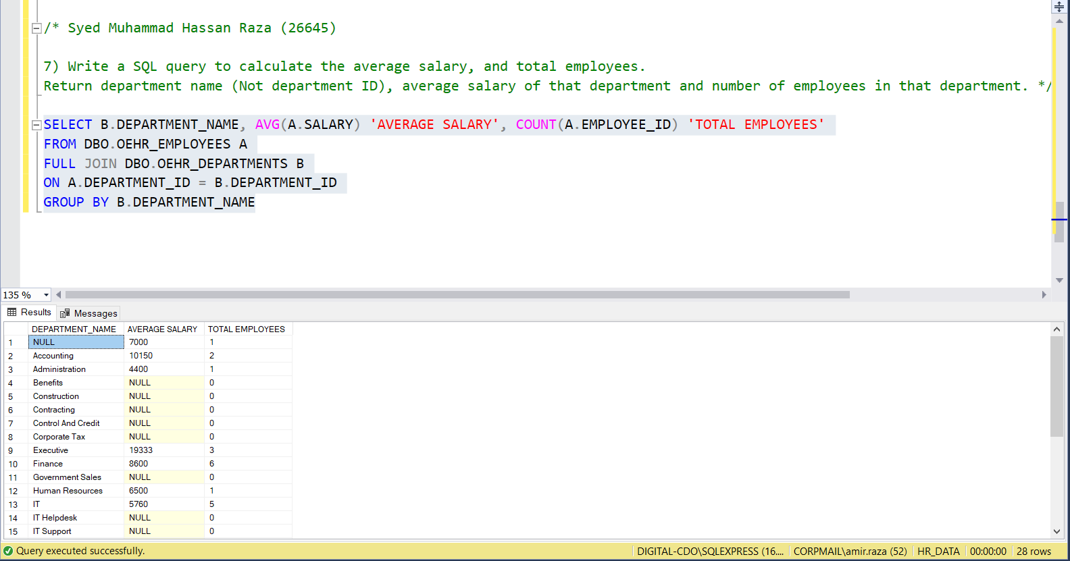

**8) Write a SQL query to find the department name and first and last name of the manager.**

SELECT A.DEPARTMENT_NAME, B.FIRST_NAME, B.LAST_NAME

FROM DBO.OEHR_DEPARTMENTS A

INNER JOIN DBO.OEHR_EMPLOYEES B

ON A.MANAGER_ID = B.MANAGER_ID

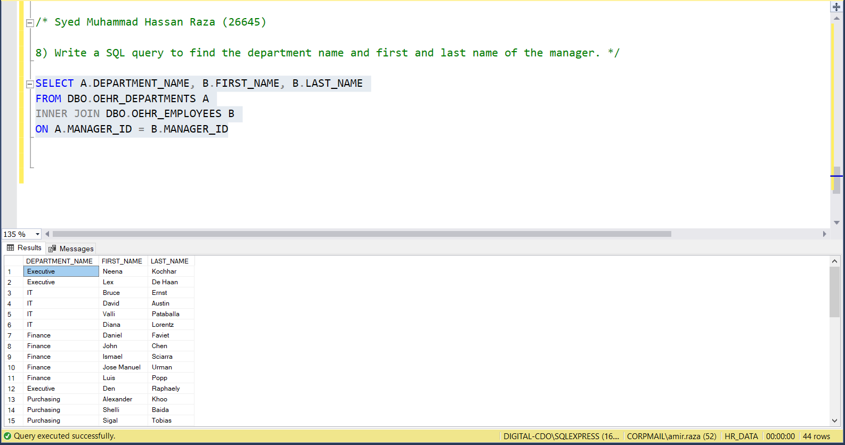

**9) Write a SQL query to find the department name, department ID, and number of employees in each department whose salary is greater than 10,000.**

SELECT B.DEPARTMENT_NAME, A.DEPARTMENT_ID, COUNT(*)

FROM DBO.OEHR_EMPLOYEES A

INNER JOIN DBO.OEHR_DEPARTMENTS B

ON A.DEPARTMENT_ID=B.DEPARTMENT_ID

WHERE SALARY > 10000

GROUP BY B.DEPARTMENT_NAME, A.DEPARTMENT_ID

